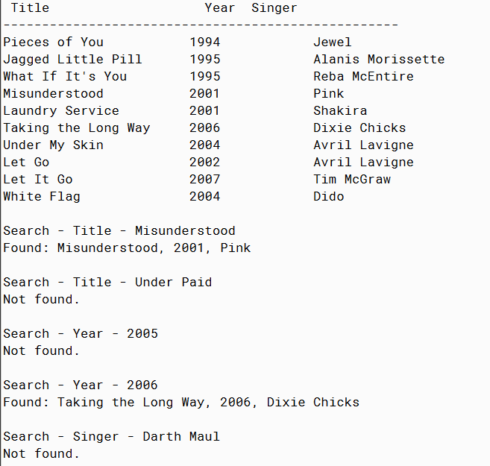

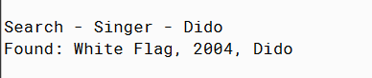

PMR: This was also an easy projects since it built on the previous project. I tried to use different music and any projects that includes something I like is fun to do. I look forward to the future projects.

/\*\*

\* Music2 interface

\*

\*

\* author Anika Jallipalli

\*

\*/

public class Music2

{

// instance variables

private String title;

private int year;

private String singer;

/\*\*

\* Constructor for objects of class Music2

\*/

public Music2(String t, int l, String p)

{

// initialise instance variables

title = t;

year = l;

singer = p;

}

public void settitle(String t)

{

title = t;

}

public String gettitle()

{

return title;

}

public void setyear(int l)

{

year = l;

}

public int getyear()

{

return year;

}

public void setsinger(String p)

{

singer = p;

}

public String getsinger()

{

return singer;

}

public String toString()

{

return String.format("%-18s", title) + "\t" + String.format("%-10s", year) +

"\t" + String.format("%-15s", singer);

}

}

/\*\*

\* Tests Music2

\*

\*

\* @author Anika Jallipalli

\*

\*/

public class TestMusic2

{

public static void main(String[] args)

{

int test = 0;

Music2[] myMusic2 = new Music2[10];

myMusic2[0] = new Music2("Pieces of You", 1994, "Jewel");

myMusic2[1] = new Music2("Jagged Little Pill", 1995, "Alanis Morissette");

myMusic2[2] = new Music2("What If It's You", 1995, "Reba McEntire");

myMusic2[3] = new Music2("Misunderstood", 2001, "Pink");

myMusic2[4] = new Music2("Laundry Service", 2001, "Shakira");

myMusic2[5] = new Music2("Taking the Long Way", 2006, "Dixie Chicks");

myMusic2[6] = new Music2("Under My Skin", 2004, "Avril Lavigne");

myMusic2[7] = new Music2("Let Go", 2002, "Avril Lavigne");

myMusic2[8] = new Music2("Let It Go", 2007, "Tim McGraw");

myMusic2[9] = new Music2("White Flag", 2004, "Dido");

printMusic2(myMusic2);

myMusic2 = insertionSort(myMusic2);

test = searchTitle(myMusic2, "Misunderstood");

System.out.println("Search - Title - Misunderstood");

if (test != -1)

{

System.out.println("Found: " + myMusic2[test].gettitle() + ", " + myMusic2[test].getyear() + ", " + myMusic2[test].getsinger());

}

else

{

System.out.println("Not found.");

}

System.out.println();

test = searchTitle(myMusic2, "Under Paid");

System.out.println("Search - Title - Under Paid");

if (test != -1)

{

System.out.println("Found: " + myMusic2[test].gettitle() + ", " + myMusic2[test].getyear() + ", " + myMusic2[test].getsinger());

}

else

{

System.out.println("Not found.");

}

System.out.println();

searchYear(myMusic2, 2005);

searchYear(myMusic2, 2006);

searchSinger(myMusic2, "Darth Maul");

searchSinger(myMusic2, "Dido");

}

public static void printMusic2(Music2[] r)

{

System.out.printf("%-25s%-6s%-20s\n", "Title", "Year", "Singer");

System.out.println("---------------------------------------------------");

for(int i = 0; i < r.length; i++)

{

System.out.println(r[i]);

}

System.out.println();

}

public static Music2[] insertionSort(Music2[] r)

{

Music2[] sorted = new Music2[r.length];

for ( int i = 0 ; i < r.length ; i++ )

{

String next = r[i].gettitle();

int insertindex = 0;

int k = i;

while ( k > 0 && insertindex == 0 )

{

if ( next.compareTo( sorted[k - 1].gettitle() ) > 0 )

{

insertindex = k;

}

else

{

sorted[k] = sorted[k - 1];

}

k--;

}

sorted[ insertindex ] = r[i];

}

return sorted;

}

public static int searchTitle(Music2[] r, String toFind )

{

int high = r.length;

int low = -1;

int probe;

while ( high - low > 1 )

{

probe = ( high + low ) / 2;

if ( r[probe].gettitle().compareTo(toFind) > 0)

{

high = probe;

}

else

{

low = probe;

}

}

if ( (low >= 0) && (r[low].gettitle().compareTo(toFind) == 0 ))

{

return low;

}

else

{

return -1;

}

}

public static void searchYear(Music2[] r, int toFind)

{

int found = 0;

System.out.println("Search - Year - " + toFind);

for(int i = 0; i < r.length; i++)

{

if (r[i].getyear() == toFind)

{

System.out.println("Found: " + r[i].gettitle() + ", " + r[i].getyear() + ", " + r[i].getsinger());

found++;

}

}

if (found == 0)

{

System.out.println("Not found.");

}

System.out.println();

}

public static void searchSinger(Music2[] r, String toFind)

{

int found = 0;

System.out.println("Search - Singer - " + toFind);

for(int i = 0; i < r.length; i++)

{

if (r[i].getsinger().compareTo(toFind) == 0)

{

System.out.println("Found: " + r[i].gettitle() + ", " + r[i].getyear() + ", " + r[i].getsinger());

found++;

}

}

if (found == 0)

{

System.out.println("Not found.");

}

System.out.println();

}

}